**Software Requirements Specification**

**For project LearnHub**

**Prepared by:**

**Trần Tấn Đạt**

**Lê Hữu Huy**

**Nguyễn Phương Tâm Tâm**

**Vũ Mạnh Khải**

**Lê Đức Nam**

**November 11, 2024**

**Table of contents**

1. **Introduction** 1.1 Background 1.2 Business opportunity 1.3 Business Objectives 1.4 Vision Statement
2. **Overall Description** 2.1. Product Perspective 2.2. User Classes and Characteristics 2.3. Operating Environment 2.4. Design and Implementation Constraints 2.5. Assumptions and Dependencies
3. **System Feature** 3.1 Use case 3.2 Use Case Specification
4. **Data Requirements** 4.1 Logical Data Model 4.2 Data dictionary
5. **External Interface Requirements** 5.1 User interfaces 5.2 Software interface
6. **Quality Attributes** 6.1 Usability Requirements 6.2 Performance Requirements 6.3 Security Requirements 6.4 Availability Requirements 6.5 Robustness Requirements 6.6 Wireframe 6.8 Prototype
7. **Swimlane**
8. **State machine**
9. **Sequence diagram**
10. **Class diagram**

**7. Swimlane** 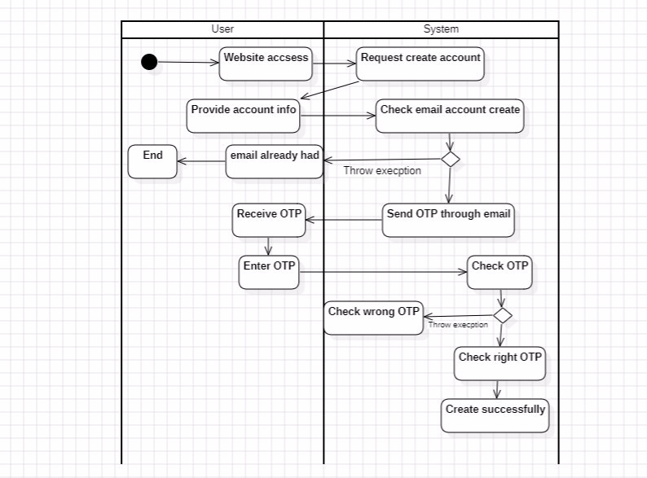

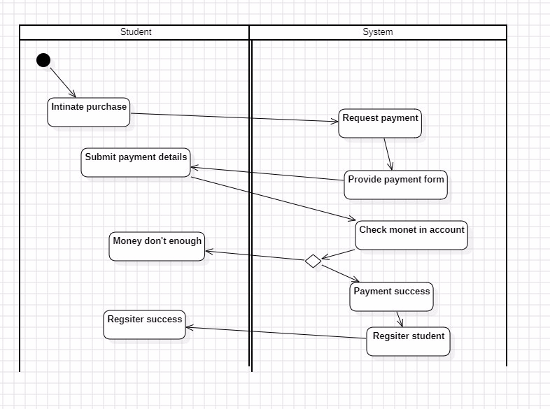

**8. State machine**

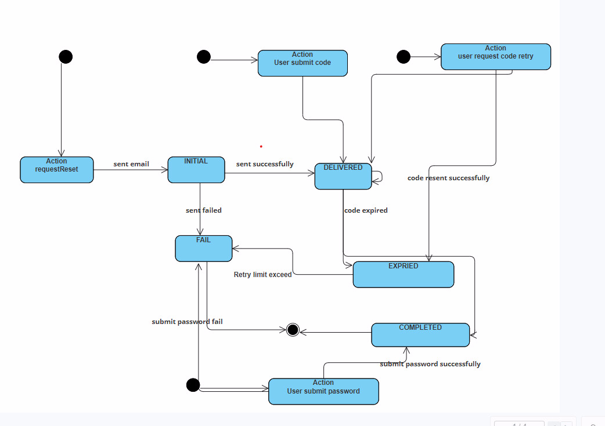

Untitled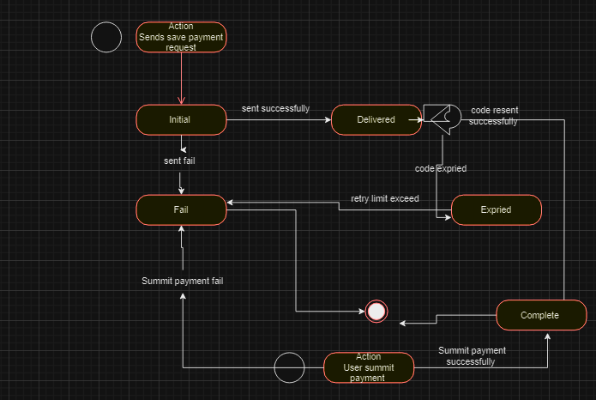

**9. Sequence diagram**

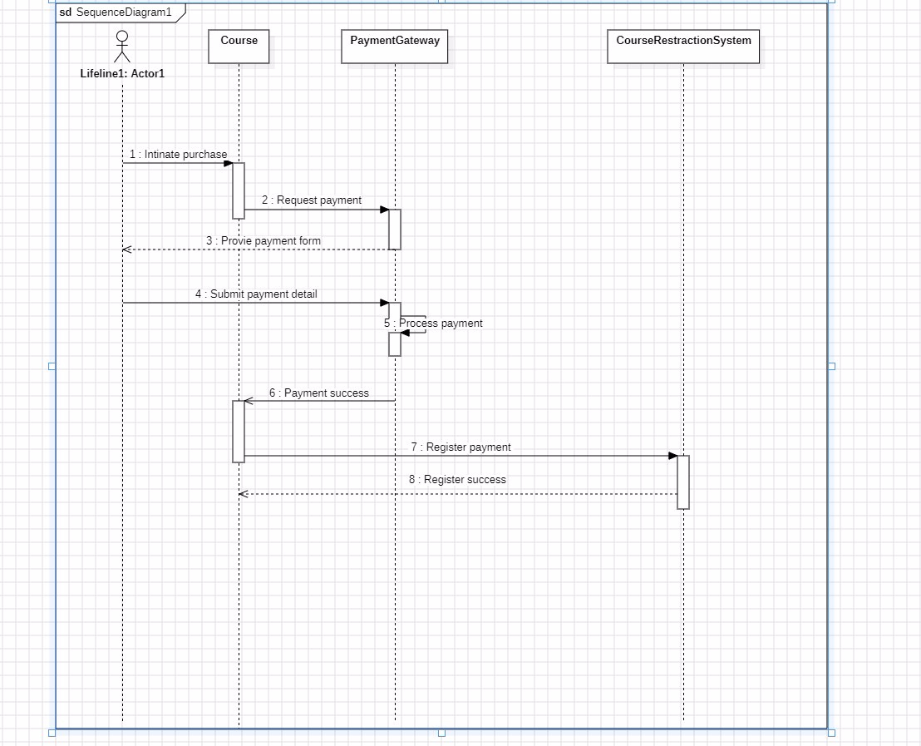

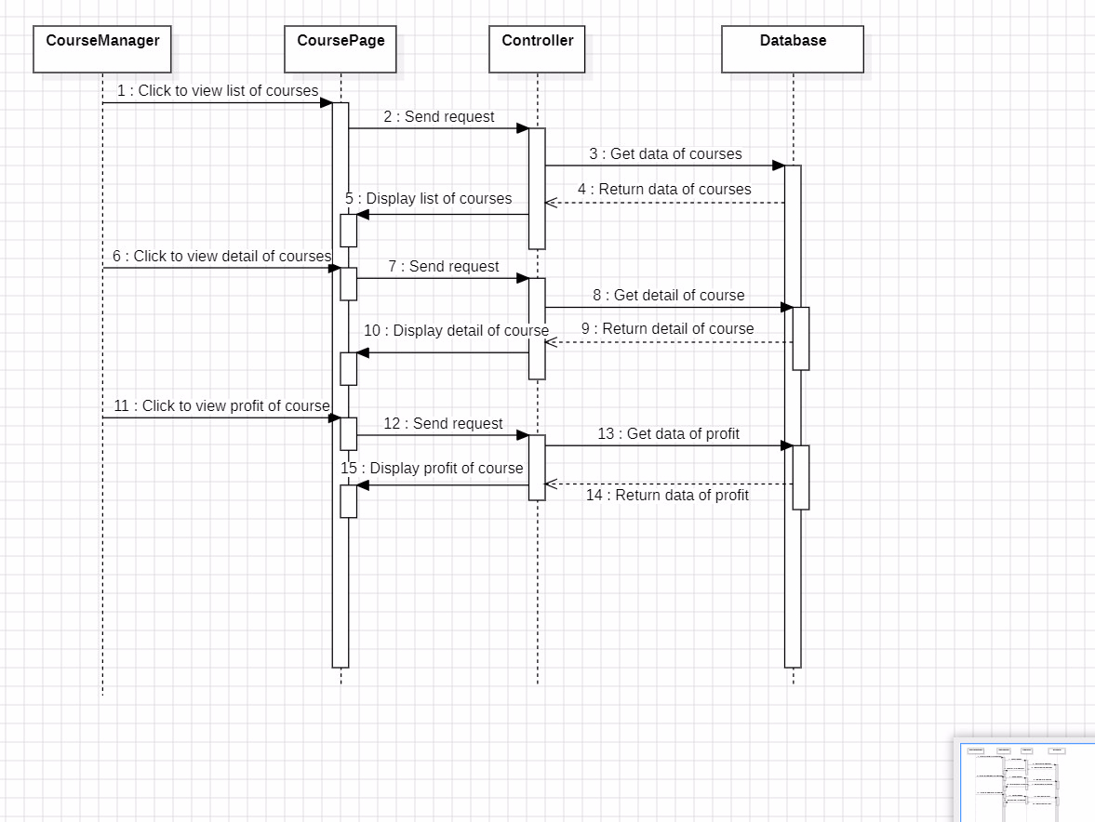

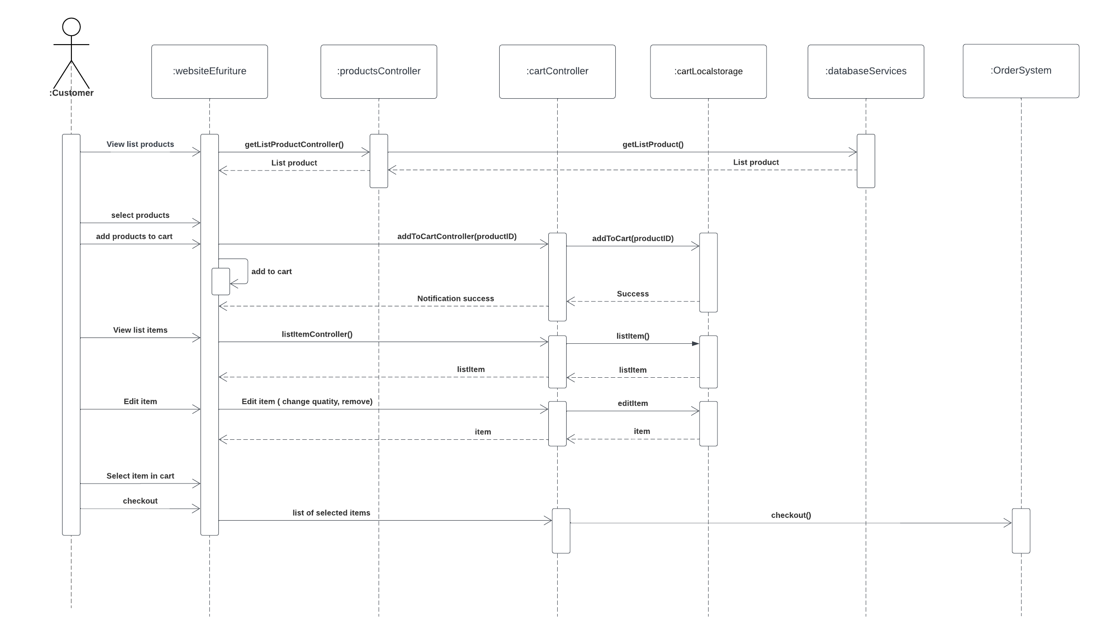

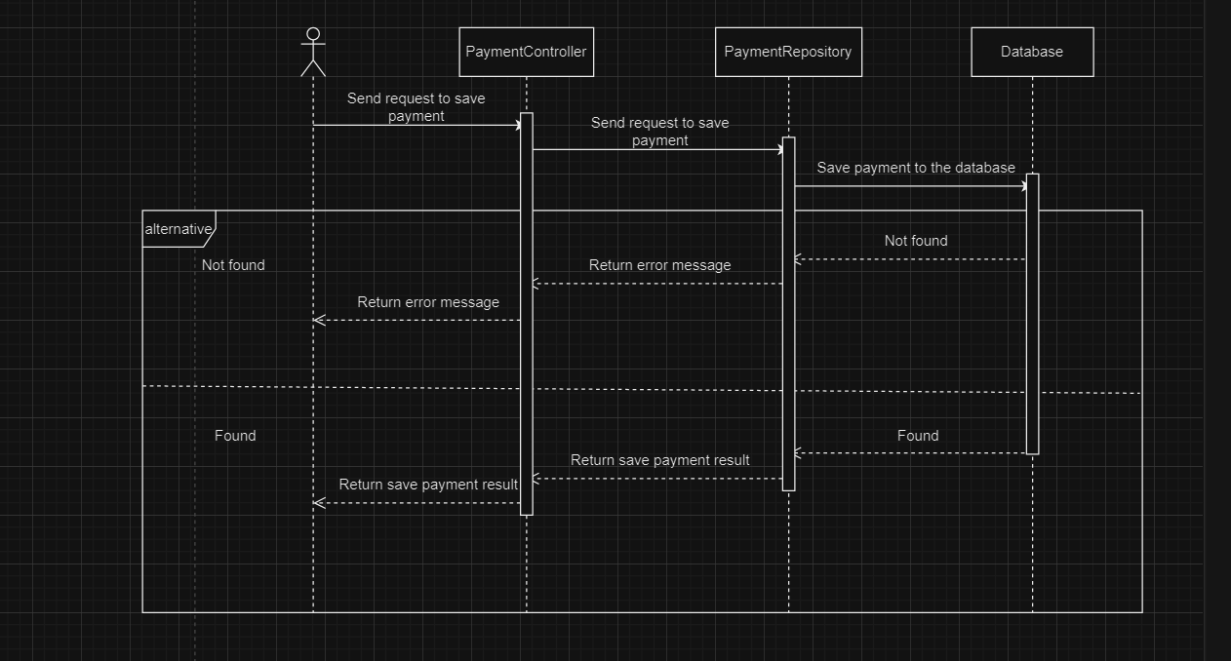

Untitled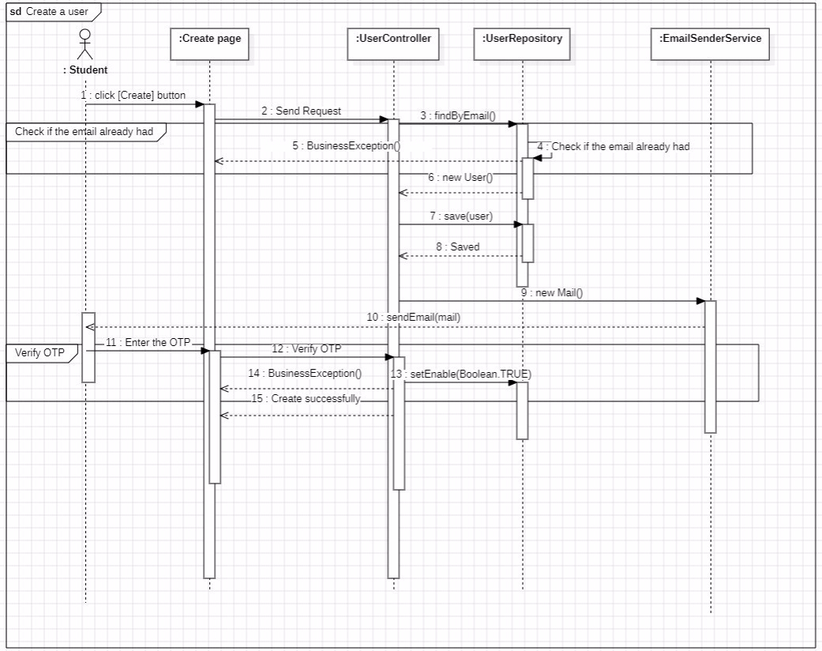

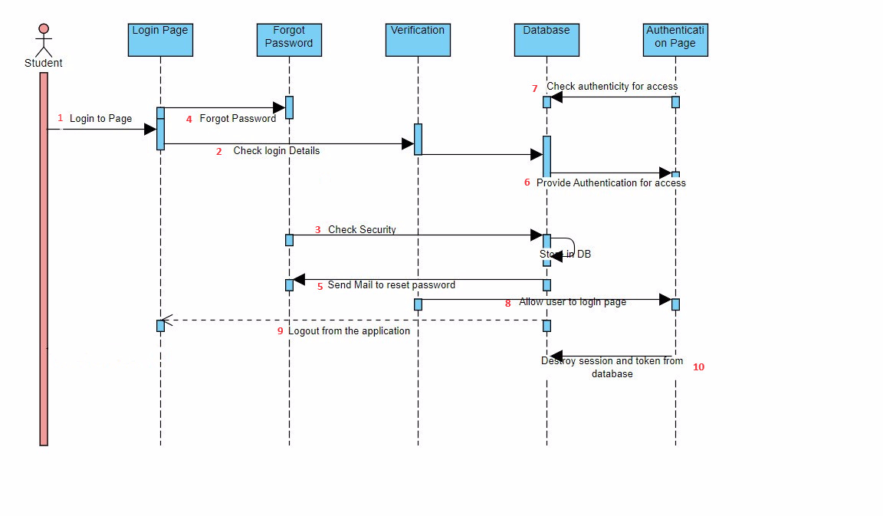

**10. Class diagram**

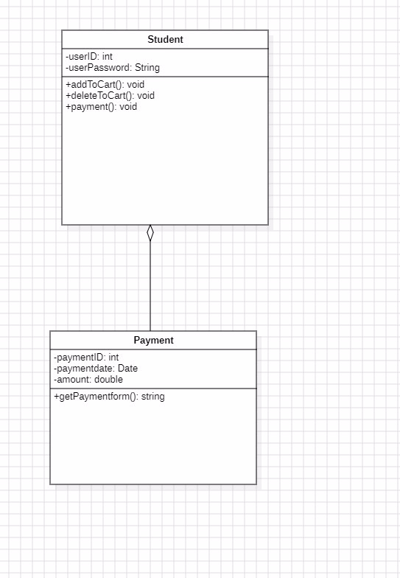

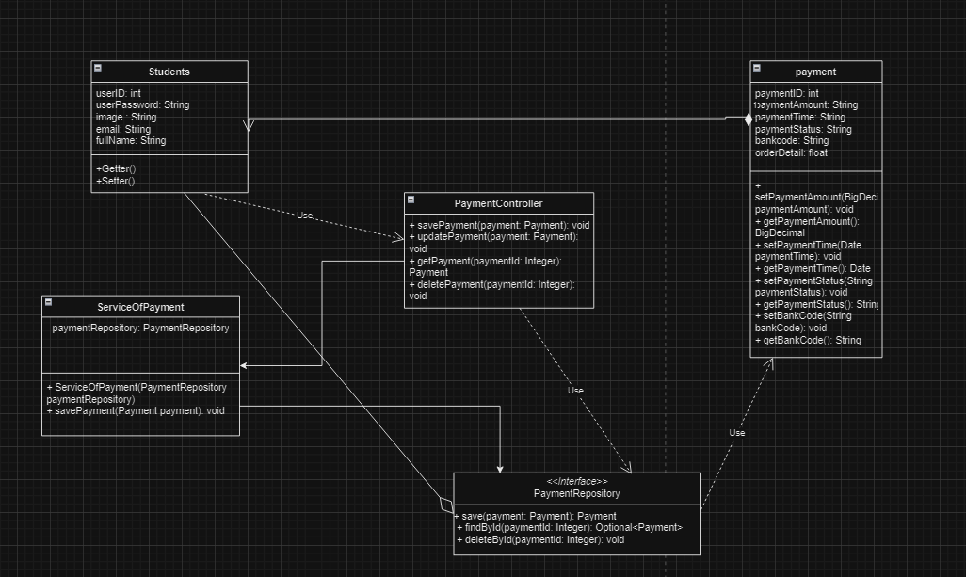

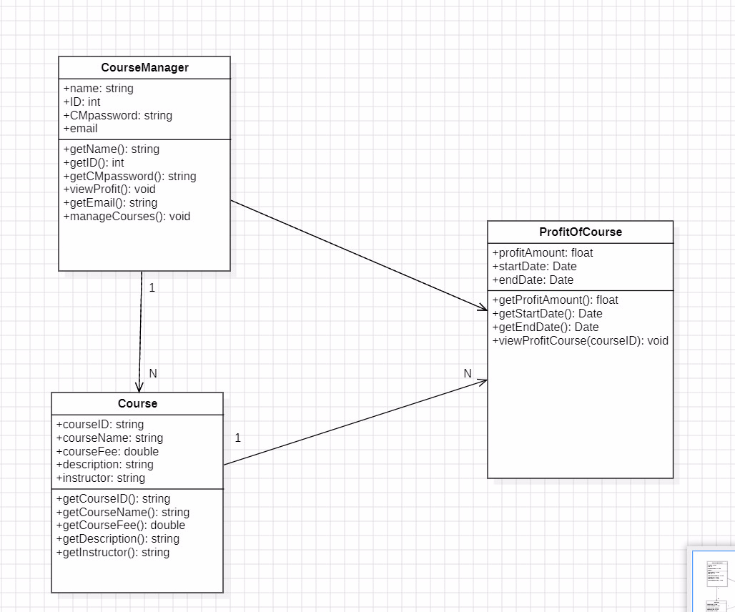

Untitled